 | SR UNIVERSITY  Campus Warangal
 | Program: II - B. Tech (CS& AI) Batch: 57
 | Name: U. STEPHEN Reg. No:2503A54026
 | Department: Computer Science and AI Semester: I
 | AI Assisted Coding-Assignment Date: 18-09-2026
ASSIGNMENT-07
- Question
Q1. Class with Conditional Logic – Employee Salary
Scenario:
An AI coding assistant is used to develop a simple employee salary management program.
Task:
Using AI-assisted code completion, write a Python class Employee that:
- Stores employee name and basic salary.
- Has a method calculate_bonus() that:
  - Returns 10% of salary if salary is ₹50,000 or above.
  - Returns 5% of salary otherwise.
- Has a method display_details() to display the employee name, salary, and bonus.
- Create at least two employee objects and test the class.

- Prompt
Create a Python program using an Employee class with name and basic_salary. Calculate a 10% bonus if salary ≥ ₹50,000, otherwise 5%. Calculate and display the total salary. Create two employee objects and test both conditions.

- Code
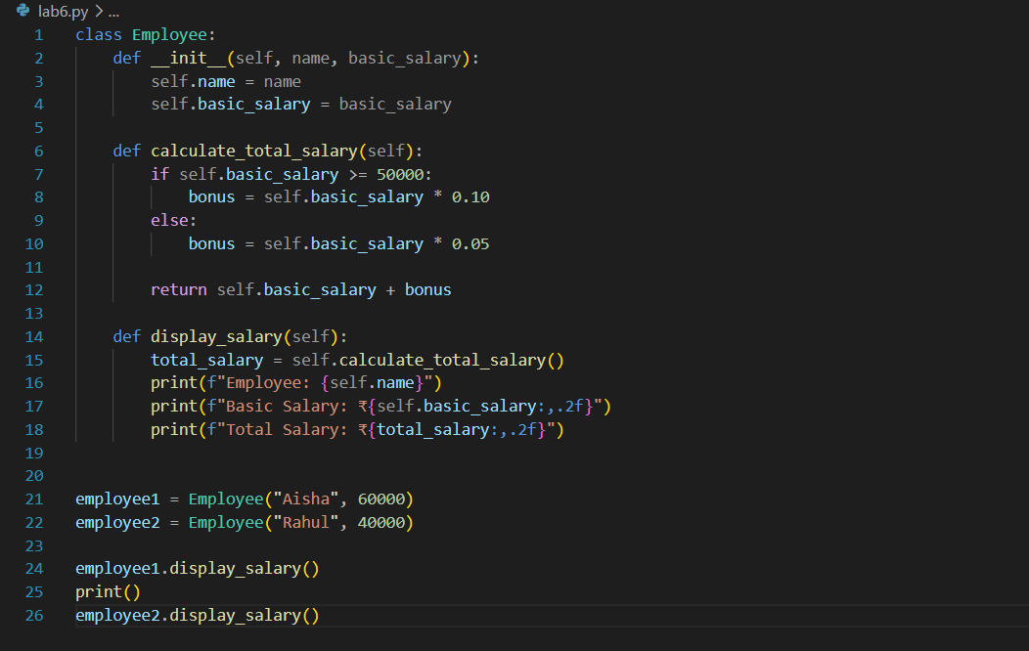

- Output
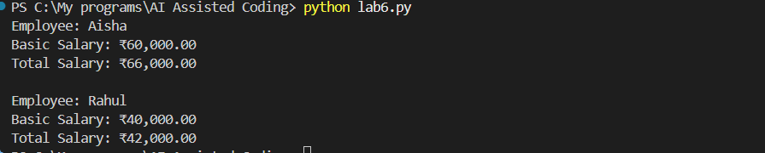
- Observation
Aisha’s salary is ₹60,000, so she receives a 10% bonus of ₹6,000. Total salary: ₹66,000.
Rahul’s salary is ₹40,000, so he receives a 5% bonus of ₹2,000. Total salary: ₹42,000.
The program correctly tests both salary conditions.

1.QUESTION
Q2. Loop and Conditional Logic – Student Marks
Scenario:
A teacher wants to analyze the marks of students using an AI coding assistant.
Task:
Using AI-assisted code completion, write a Python program that:
- Accepts a list of student marks.
- Uses a loop to process each mark.
- Displays:
  - "Distinction" for marks ≥ 75
  - "Pass" for marks ≥ 40 and < 75
  - "Fail" for marks < 40
- Ignores invalid marks outside 0–100.
- Calculates and displays the number of students in each category.
- Test the program with a suitable list of marks.
2.PROMPT
create a python program which accepts lists of students marks and uses loop to process each mark
and if marks >= 75 -- distinction
marks >=40 and <75 -- pass
marks <40 -- fail
if marks outside 0 and 100 invalids
create each test case and test all

3. CODE
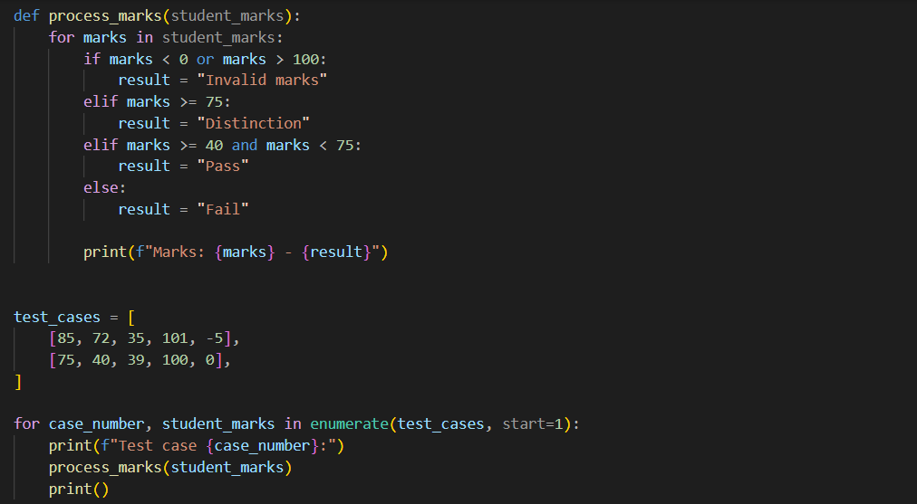
4.OUTPUT
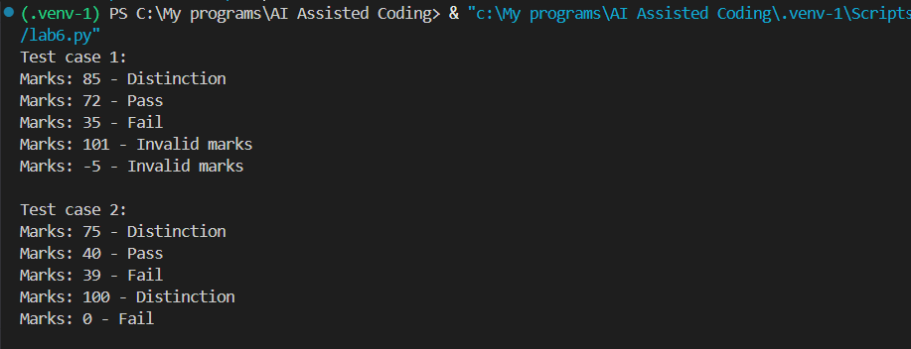

5.OBSERVATION
The program correctly processes every mark using a loop:
- 85, 75, and 100 → Distinction
- 72 and 40 → Pass
- 35, 39, and 0 → Fail
- 101 and -5 → Invalid marks

Question 3 :
Class + Loop – Product Inventory
Scenario: A small store wants to maintain product inventory using a Python program generated with AI assistance.
Task: Using AI-assisted code completion, create a class Product that:
• Stores product name, price, and quantity.
• Has a method total_value() that calculates price × quantity.
• Create a list of multiple Product objects.
• Use a loop to calculate the total inventory value.
• Display the products whose quantity is less than 5 as "Low Stock".
• Test the program with at least three products.

2. Prompt
Create a Python Product class with product name, price, and quantity. Calculate the total value of each product using price × quantity. Use a loop to find the total inventory value and display products with quantity less than 5 as Low Stock. Test with three products.

3.CODE
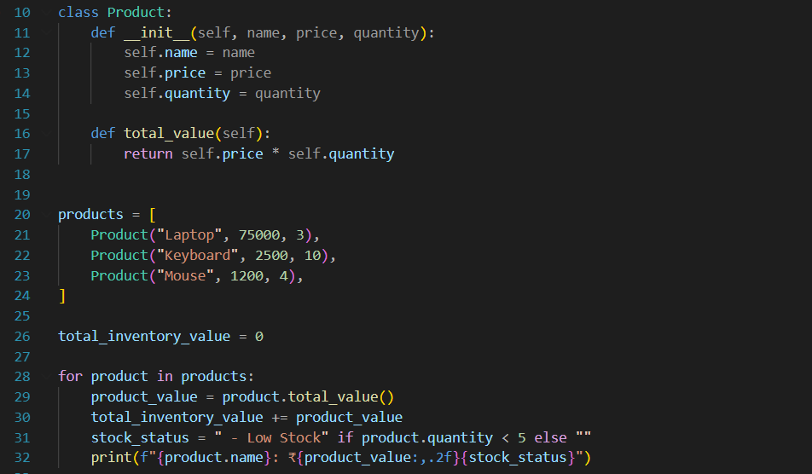
4.OUTPUT
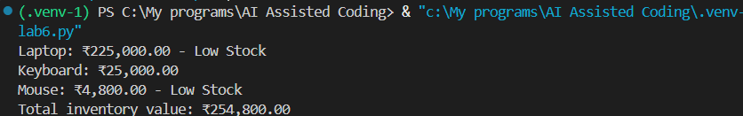
5.OBSERVATION
The program successfully processes all three products, calculates each product’s total value, identifies low-stock products, and calculates the total inventory value of ₹254,800.00.

Q4. Class + Loop + Nested Conditions – Electricity Bill
Scenario:
An electricity board wants to calculate bills based on units consumed.
Task:
Using AI-assisted code completion, create a Python class ElectricityBill that:
- Stores the consumer name and units consumed.
- Calculates the bill using:
  - First 100 units → ₹2/unit
  - 101–200 units → ₹3/unit
  - Above 200 units → ₹5/unit
- Uses appropriate loops and conditional statements where required.
- Displays the consumer name, units, and total bill.
- Create at least three objects and display their bills.
Test the program with different unit values, including an edge value such as 100 or 200.

2.PROMPT
Create a Python ElectricityBill class to calculate electricity bills based on units consumed. Charge ₹2 per unit for the first 100 units, ₹3 per unit for units 101–200, and ₹5 per unit above 200. Display the consumer name, units, and total bill. Test with three consumers.and run program with different unit values, including an edge value such as 100 or 200
3.code
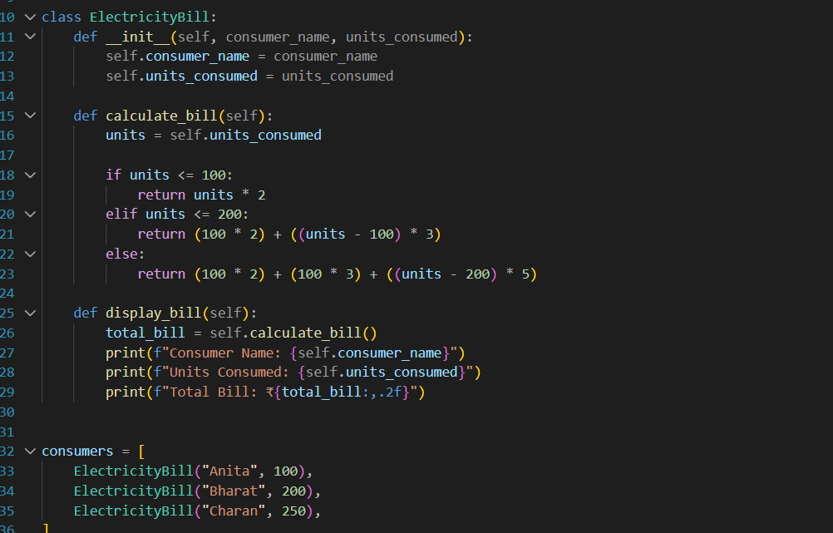

4.OUTPUT
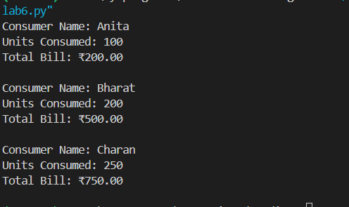
5.OBSERVATION
The program correctly applies progressive electricity rates:
- First 100 units at ₹2 per unit
- Units 101–200 at ₹3 per unit
- Units above 200 at ₹5 per unit

